Subject: Refresh Your Office for 2025: Boost Creativity & Productivity!

Dear [Recipient's Name],
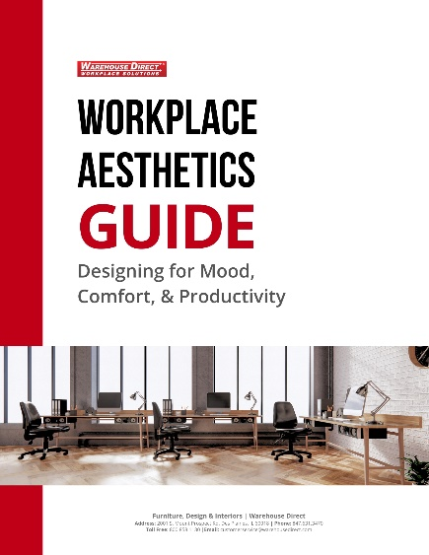
As we head into 2025, it’s a great time to refresh your office to boost creativity, productivity, and overall well-being. Here are a few ways to transform your workspace:
- Pop Chairs: New Product – Available for next-day delivery. Add a fun, colorful touch to collaboration zones and informal meeting areas. These chairs are designed to energize the space and spark creativity.
- Aesthetic Checklist: Check out our Aesthetic Checklist for helpful tips on how to create an office environment that promotes focus, comfort, and productivity.
- Tailored Advice: Our experts are here to help you design a workspace that reflects your company’s values and supports your team’s well-being. Contact us today to learn more!
Let’s make 2025 your most productive year yet!

