Subject: Kickstart 2025 with the Essential Food Service Catalog!
Dear [Recipient's Name],
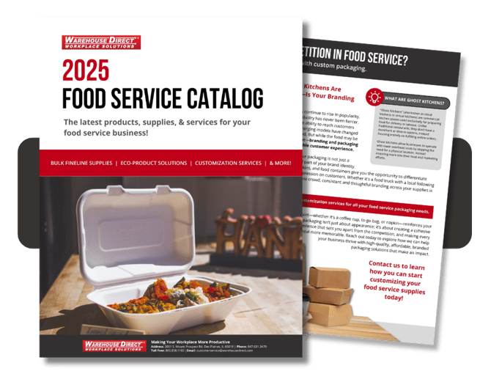

With the holiday season behind us, now is the perfect time to focus on growing your food service business in 2025. Whether you're looking to embrace sustainable practices, upgrade your catering supplies, or create standout branding, the Warehouse Direct 2025 Food Service Catalog is here to help. Packed with the essentials you need; this catalog offers everything to keep your business ahead of the competition.
Sustainability continues to be a priority, especially with the growing number of local regulations like Evanston’s new plastic bag ordinance. Starting this year, all plastic and paper bags must meet specific eco-friendly standards, such as using compostable plastic or 40% recycled paper. To help you adapt, we’re offering biodegradable alternatives that combine convenience with reduced environmental impact. Contact us today for a sample of these innovative products and get ahead of similar trends in your area.
Standing out from competitors like food trucks and ghost kitchens means making your packaging work harder for you. Custom-branded bags, napkins, and seasonal designs are simple yet effective ways to showcase your name with every order. From bold Southern Champion bakery boxes to personalized takeout supplies, our catalog has creative options to help elevate your brand without breaking the bank.
Take the first step toward achieving your 2025 goals—download our catalog to explore these essential products and more. For all your food service needs, don’t hesitate to contact our workplace experts and let’s make this your best year yet!
Best regards,
[Your Full Name]
[Your Email Address]
[Your Phone Number]

