Subject: Transform Your Breakroom for 2025!

Dear [Name],
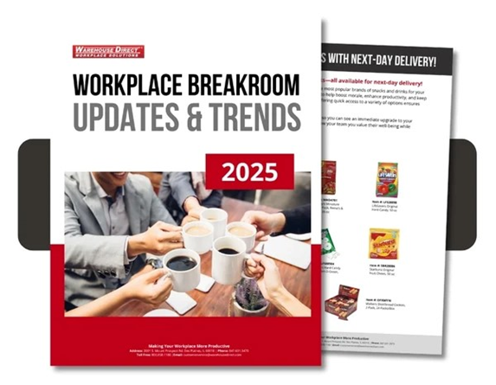
As we head into 2025, it's the perfect time to reimagine your breakroom with products and services that enhance productivity, creativity, and well-being. Here's how we can help:
- Download the Free 2025 Workplace Breakroom Catalog!
Get a fresh perspective on breakroom trends and updates with our free 2025 Workplace Breakroom: Updates & Trends catalog.
- Breakroom Bestsellers - Delivered the Next Day!
Want to update your breakroom instantly? Check out our most popular snacks and beverages, available for next-day delivery!
- Coffee Machine Service for 2025
Ensure your coffee machine is ready for the new year! Schedule a service check to avoid expensive repairs and extend your brewer's life.
- Sustainable Hydration Options
Stay ahead with eco-friendly alternatives to bottled water.

Ready to elevate your breakroom? Contact us today for expert recommendations and personalized service!

